Operational Concept Description (OCD)

Mission Science Information and Data Management System 3.0

Team 03

Fei Yu: Project Manager, Life Cycle Planner
Yinlin Zhou: Prototyper, Operational Concept Engineer
Yunpeng Chen: Requirements Engineer
Jingwen Peng: Builder, UML Modeler
Chenguang Liu: System Architect
Steven Lee: Requirements Engineer, IIV&V, Quality Focal Point

2 December 2013

Version History
Date | Author | Version | Changes made | Rationale
09/27/13 | YZ | 1.0 | - Introduction  - Purpose of the OCD  - Status of the OCD  - Program Model  - Benefits Chain Diagram  - System Boundary and Environment Diagram | - Initial Team 03 draft of Operational Concept Description
09/27/13 | CL | 1.0 | - Infrastructure  - Artifacts | - Initial Team 03 draft of Operational Concept Description
09/27/13 | JP | 1.0 | - Current Business Workflow | - Initial Team 03 draft of Operational Concept Description
10/14/13 | YZ | 1.1 | - Complete rest of the OCD | - First complete version of Operational Concept Description
10/23/13 | YZ | 2.0 | - Improve the phrasing used in previous version | - Improved version of Operational Concept Description
10/23/13 | SL | 2.1 | - Update content for grammar, spelling, and term consistency | - Final draft for DC package.
12/2/13 | SL | 3.0 | - No updates. | - Draft for TRR package.

Table of Contents
Operational Concept Description (OCD) i
Version History i
Table of Contents ii
Table of Tables iii
Table of Figures iv
1. Introduction 1
2. Shared Vision 2
2.1 Overview of the system 2
2.2 Benefits Chain 3
2.3 System Boundary and Environment 4
3. System Transformation 5
3.1 Information on Current System 5
3.2 System Objectives, Constraints and Priorities 8
3.3 Proposed New Operational Concept 10
3.4 Organizational and Operational Implications 12

Table of Tables
Table 1: The Program Model of MSIDMS 3.0 2
Table 2: MSIDMS 3.0 Artifacts 5
Table 3: Capability Goals of MSIDMS 3.0 8
Table 4: Level of Service Goals of MSIDMS 3.0 8
Table 5: Relation to Current System 9

Table of Figures
Figure 1: Benefits Chain Diagram of MSIDMS 3.0 3
Figure 2: System Boundary and Environment Diagram of MSIDMS 3.0 4
Figure 3: Current Business Workflow Diagram of MSIDMS 3.0 7
Figure 4: Element Relationship Diagram of MSIDMS 3.0 10
Figure 5: Business Workflow Diagram of MSIDMS 3.0 11

Introduction

  - Purpose of the OCD
This document provides the shared visions and goals of the stakeholders of the Mission Science Information and Data Management System 3.0. The key stakeholders of the project are the “Instructor/Administrator” (Darin Gray) as the client, project coordinator and the main system handler, the “USC student workers” as the users, and the “developers.”

  - Status of the OCD
The status of the OCD is currently at the version number 2.0 in the Development Phase.

Shared Vision

Overview of the system
Based on the Win-Win negotiation and client meeting, we are able to come out with the following table.
Table 1: The Program Model of MSIDMS 3.0
Assumptions
- STEM projects are necessary for students to improve their learning skills
- The management of programs can decrease time cost
- The reported data is required as proof for funding
- The open-ended projects can help design the activities more flexibly
- The management of the inventory can improve inventory tracking
Stakeholders | Initiatives | Value Propositions | Beneficiaries
- Developers  - Instructor/Administrator  - USC Students Workers | - Develop systems  - Create and design STEM related projects  - Design open-ended activities | - For students to learn about STEM  - Decrease amount of time managing programs  - Easy report of data for funding  - Improve kids critical thinking abilities  - Increase retention in program  - Increase flexibility to design activities  - Better inventories tracking | - Instructor/Administrator  - Kids, elementary school students  - USC student workers  - Funders
Cost  - Development costs  - Maintenance costs  - Data synchronized costs |  | Benefits  - Save time managing programs  - Increase availability of report data for funding  - Improve kids critical thinking abilities  - Increase retention in program  - Increase flexibility in activity design  - Save time managing inventories

Benefits Chain
Figure 1: Benefits Chain Diagram of MSIDMS 3.0
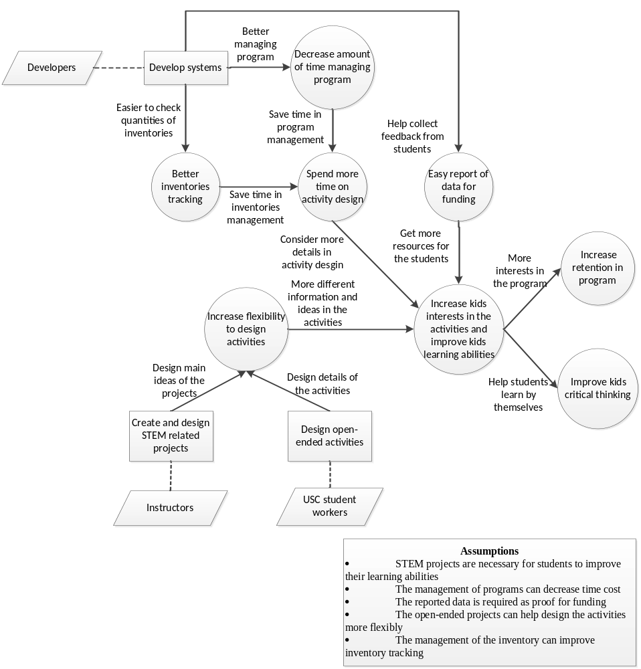

System Boundary and Environment
Figure 2: System Boundary and Environment Diagram of MSIDMS 3.0
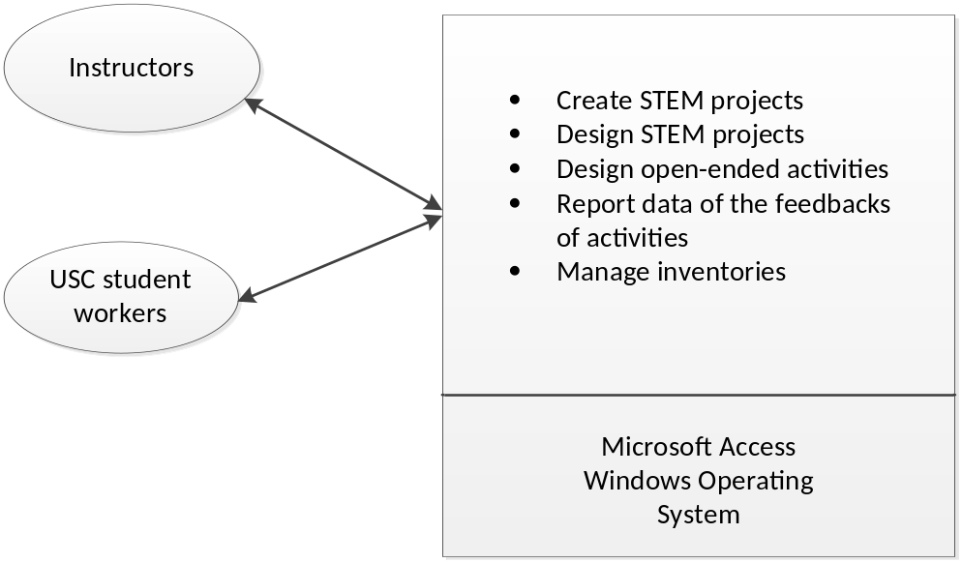

System Transformation

Information on Current System

Infrastructure
- Operating System: Windows 7
- Hardware: Flash drive/ USB disk
- Hardware: The minimum hardware requirement is 1GB RAM or more, and it is recommended to have a fast connection to the Viterbi IT fileserver.
- Software: The minimum software requirements are a Microsoft Operating Platform of Windows 7 or later and Microsoft Access 2010 or later. It is also required to have access to the location of the Access file on the Viterbi IT fileserver.
- Language: Visual Basic

Artifacts
Table 2: MSIDMS 3.0 Artifacts
Artifact | Description | Requested/ Shown/ Received | Planned Delivery Date
Enrollment Form | Record the background of each elementary school student, including the information about his/her address, race, and parents. | Received | 2013.09.20
Sign-In Sheet | Record of which class the elementary school student attended. | Received | 2013.09.20
Pre-/Post-Survey | When the student signs up, they need to take a survey about what they already know. Another survey will be administered at the end of the semester to know what they have learned. The two surveys will be administered before and after the project as well. | Received | 2013.09.20
User Manual | A reference guide to all of the functions of the revised Mission Science Information and Database System. It includes fixes to many of the issues with the previous system, including re-applying the idea of role-based access, using a simpler approach. | Received | 2013.09.16
Copy of existing system | Mission Science Information and Data Management System 2.0 | Received | 2013.09.16
Access to Blackboard | Developers access to the Blackboard to read user comments of USC student workers to resolve system issues. | Received | 2013.09.16

Current Business Workflow
Figure 3: Current Business Workflow Diagram of MSIDMS 3.0
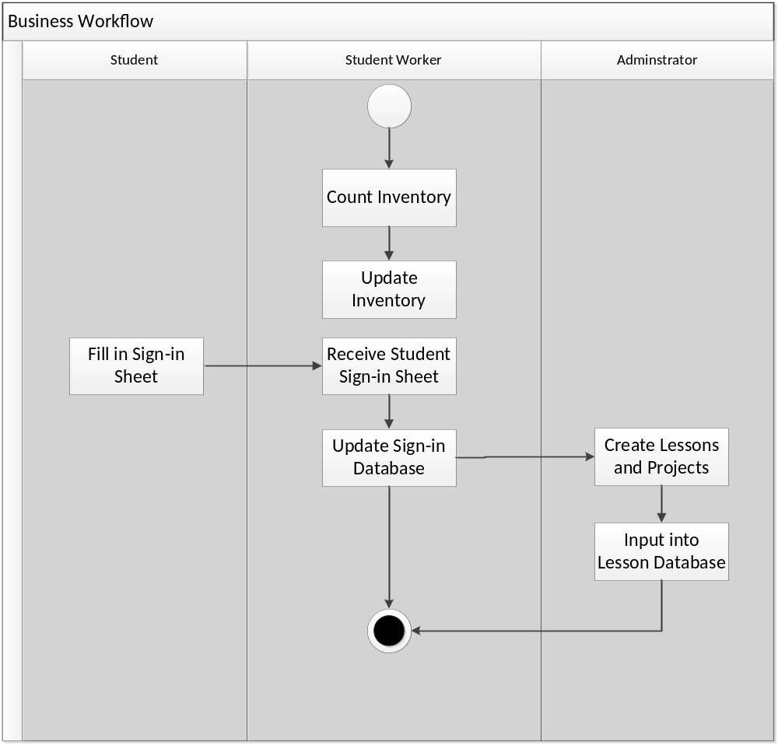

System Objectives, Constraints and Priorities

Capability Goals
Table 3: Capability Goals of MSIDMS 3.0
Capability Goals | Priority Level
OC-1 STEM Project Management: Instructors should be able to create STEM projects for open-ended courses/modules in the database. USC Student Workers should then be able to create the relevant activities for the STEM projects. | Must have
OC-2 Survey Results Report System: Instructors should be able to view the results of surveys of elementary school students from the different activities. | Must have
OC-3 Inventory Management: Instructors and USC Student Workers should be able to view and reserve quantities of inventory. | Must have
OC-4 Assign Next Generation Science Standards: Instructors should be able to assign Next Generation Science Standards for existing and new project activities. | Should have
OC-5 Check Completeness of student data: The system can automatically tell the instructors which data fields are empty for every student. | Could have

Level of Service Goals
Table 4: Level of Service Goals of MSIDMS 3.0
Level of Service Goals | Priority Level | Referred Win-Win Agreements
Availability | Must have | WC_2349, WC_2347
Interoperability | Must have | WC_2593, WC_2348, WC_2592

Organizational Goals
OG-1: Improve elementary school students’ critical thinking skills
OG-2: Increase retention in programs
OG-3: Help education organization easily report of data for funding
OG-4: Increase elementary school students’ interests in science
OG-5: Help education organization get the feedbacks from students

Constraints
CO-1: Windows as an Operating System: The new system must be able to run on Windows 7 or a later version.
CO-2: Use MS Access 2010 as the tool: The new system should be implemented on MS Access 2010 or a later version.

Relation to Current System
Table 5: Relation to Current System
Capabilities | Current System | New System
Roles and Responsibilities | - Instructors and Student Workers can create projects | - Instructors can create STEM projects and Student Workers can design detailed activities of the STEM projects
User Interactions | - Users cannot accurately manage/forecast inventories. | - View quantities of inventories and reserve inventories if needed.
Infrastructure | N/A | N/A
Stakeholder Essentials and Amenities | - Survey and Report capability not available. | - View feedback from students  - Save time managing the system
Future Capabilities | N/A | N/A

Proposed New Operational Concept

Element Relationship Diagram
Figure 4: Element Relationship Diagram of MSIDMS 3.0
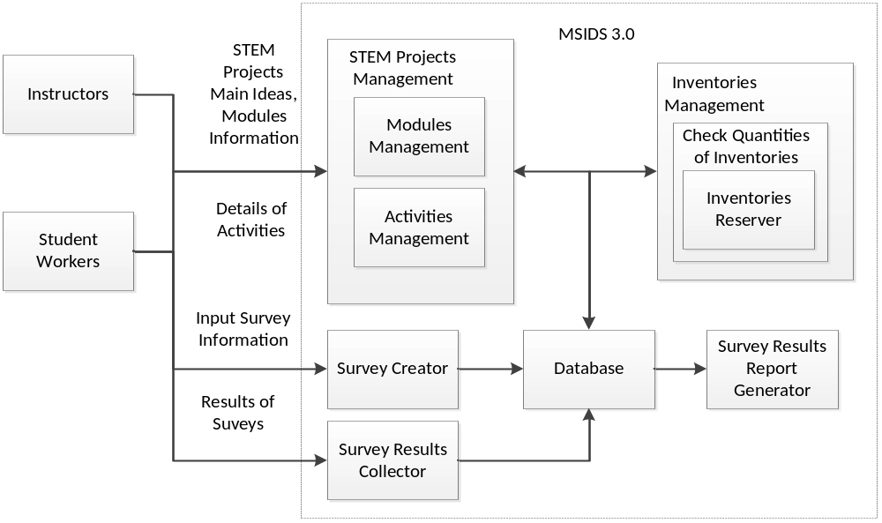

Business Workflows
Figure 5: Business Workflow Diagram of MSIDMS 3.0
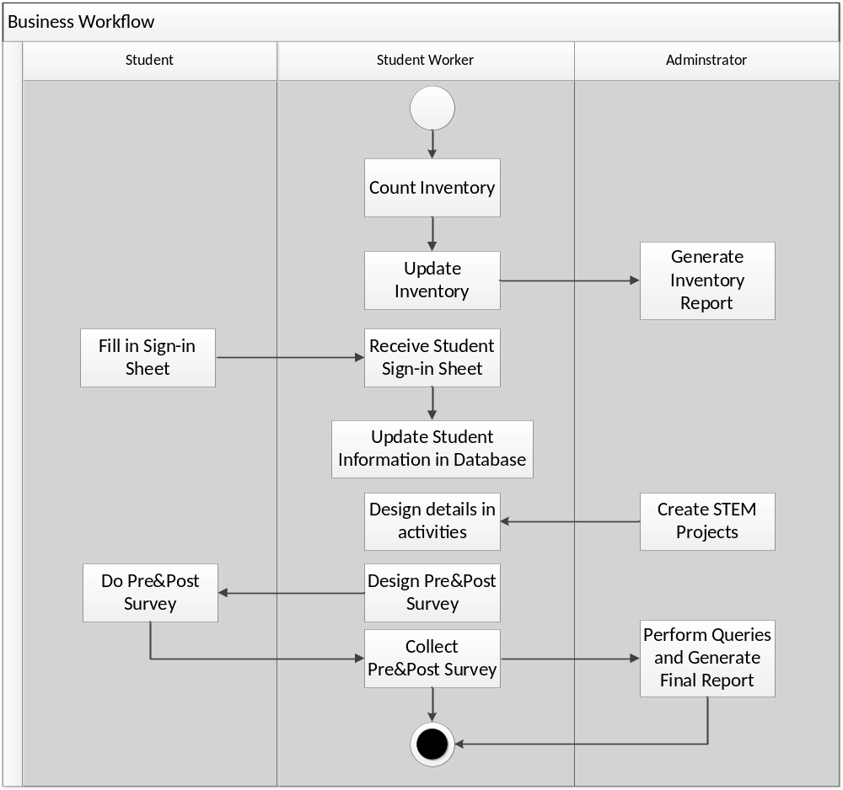

Organizational and Operational Implications

Organizational Transformations
- A STEM projects subsystem will be added to the current system.
- A Survey Management and Report Sub-system will be added to the current system.
- An Inventory Management Sub-system will be modified to help instructors and UC student workers manage the inventories more effectively and efficiently.

Operational Transformations
- Instructors can design the main ideas of the projects and let the student workers design the details.
- Instructors can see if the programs work for elementary school students according to the feedback from the pre-/post-surveys.
- Quantities of inventories can be checked prior to delivery and instructors and USC student workers can make reservations if needed.

